**Benefits of React Native**

Now that you know what React Native is, let’s explore it further and focus on the benefits that using React Native can bring. This way, you will be confident about the tool you will use to build the Little Lemon app.

In this reading, you will learn about the benefits of React Native and how to explain why it is a practical choice for building cross-platform mobile apps. This will help you decide if React Native is a good fit for your project.

**1. Uses JavaScript**

The first benefit of React Native is that it is entirely coded in JavaScript. This means you can use your existing JavaScript skills and put them to use when building React Native apps.

JavaScript has been the most popular programming language in the world for many years, and its compatibility with React Native is a huge perk for helping JavaScript developers become mobile developers.

**2. Uses React**

The next benefit of using React Native is, as you probably guessed, that it uses React.

To simplify this for you:

**JavaScript + React = React Native**

**JavaScript and React make React Native.**

React Native apps are written entirely in JavaScript using React. React is the most popular and in-demand web framework today and is used by several major companies and startups to build their web applications. With React Native, you can use React to build mobile applications.

You can also use all the principles learned in React with React Native. This means you can use the component-based architecture that comes with React. Code sharing between mobile and web platforms becomes more manageable, saving development costs.

**3. Builds Cross-Platform Native Apps**

The third benefit of using React Native is that it builds cross-platform apps on both iOS and Android. But did you know that you can’t distinguish them from an app built using native languages such as Swift or Kotlin?

With React Native, you build a real native mobile app. It is impressive since you are coding in JavaScript and rendering components native to the platform. This is one of the reasons why apps built using React Native have a superior user experience (UX).

React Native provides platform-agnostic components that map directly to the platform’s native user interface (UI) building blocks. This results in high-quality native apps that offer a great user experience.

**4. Cost Effective**

At this point, it may be no surprise to learn that React Native could save you money!

This is because React Native is a cost-effective option for teams. Teams can be smaller in size, with developers working cross-platform on the same code base. There is no need to support separate codebases for iOS and Android.

This results in faster development time. This also means that the code is easier to test and debug. Once you find a bug, it is simultaneously removed in iOS and Android. This eliminates the need to maintain multiple codebases.

All of these result in an overall reduction in costs!

**5. Developer Experience**

The last benefit is that, unlike developing traditional native mobile apps, developing React Native apps is a far superior developer experience. You will enjoy the ease of development, all the developer tools it comes with, and how straightforward it is to debug.

Let’s explore some features you can utilize to enjoy a great developer experience.

**Fast Refresh**

React Native supports fast refresh, which gives almost instant feedback for your changes in React Components while the app is running on an emulator. The quick refresh feature is a big time-saver for developers. You can see your changes on the emulator as soon as you hit save!

**Easy Debugging**

Debugging React Native apps is simple since you are essentially debugging JavaScript code.  You can use the Chrome developer tools to debug the JavaScript code. In addition, you can use the React Developer tools to debug the React Component hierarchy.

**Over-the-Air Updates**

The next feature, which is another big time-saver, is over-the-air updates. In traditional native apps, both iOS and Android, the release process can be tedious and getting approval from the app store can take several days. With React Native, you may be able to avoid this wait, depending on your changes. App Center’s Code Push is a cloud service that enables React Native developers to deploy mobile app updates directly to the users’ devices. It acts as a central repository to which developers can publish updates, and those apps can query for updates. This means small features or bug fixes can be made available to users immediately, without redistribution through the respective app stores. Features like Over the Air (OTA) updates make the React Native developer experience seamless.

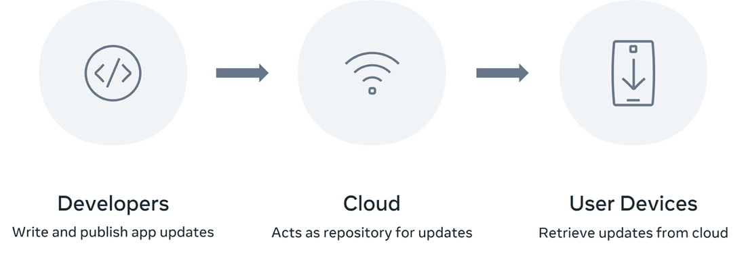

**Conclusion**

The React Native community is growing incredibly fast, and now is a great time to learn.

You should now be more familiar with the benefits of using React Native and understand why it is a fantastic tool for building cross-platform apps. Hopefully you’ll find it useful for your next project!